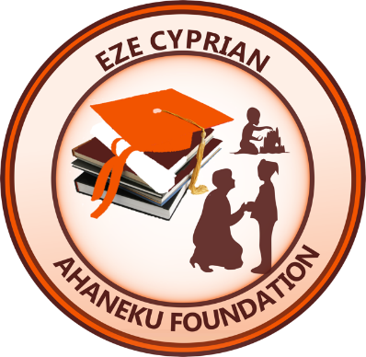October 22, 2023

**A letter to our donors.**

*Transmitted by* email

Dear Donor:

I am writing to inform you that we are in the final phase of Sacred Heart School rebuilding project. This ongoing phase involves landscaping and tree planting.

Words cannot express how grateful I and the other board members are to you our donors for your material and in-kind donations and your thoughtful support to the noble cause of rebuilding Sacred Heart School, Owere Nkalu Autonomous Community in Imo State Nigeria.

To say that what ECAF has accomplished to date would not have been possible without every single aspect of your contribution materially, physically and spiritually would be an understatement.

I would like to state that the shredding events which many of you have been part of, has been and remains a major source of fundraising for the work of the foundation of which Sacred Heart School rebuilding is a part. This is in addition to contributions from other friends of ECAF toward the rebuilding project. As a result, we wish to continue the shredding events to support other work of the foundation. We therefore lean on your continued support.

Thank you very much indeed.

Joann A. Akinyele

Joann Ahaneku Akinyele

President

*ECA Foundation is a 501 (c)(3) not-for-profit organization—Federal Tax Payer ID is 80-895752.*